LAMPIRAN A

IPT PENERAJU :

BIDANG TUJAHAN :

URUS SETIA MyLAB
BAHAGIAN PERANCANGAN KECEMERLANGAN IPT (BPKI)
JABATAN PENDIDIKAN TINGGI
KEMENTERIAN PENDIDIKAN MALAYSIA
ARAS 7, NO.2, MENARA 2
JALAN P5/6, PRESINT 5
62200 PUTRAJAYA
NO.TEL. : +603 – 8870 6952 / 6954 / 6956 /8870 6000 samb. 4579
NO. FAKS: +603 – 8870 6867
mylabbpki@mohe.gov.my

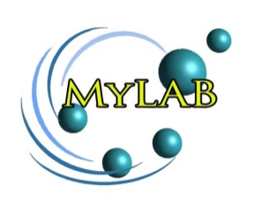

BORANG
PERMOHONAN PROJEK MALAYSIA LABORATORIES FOR ACADEMIA-BUSINESS COLLABORATION
(MyLAB) 1/2018
(Pindaan Tahun 2018)

SEKSYEN A : MAKLUMAT UMUM PROJEK

[Incomplete Form will be rejected]
A. | Tajuk Projek Yang Dicadangkan:  Title of Proposed Project:
B. | Maklumat Permohonan / Details of Application :
(i) | Nama Ketua Projek: No. Kad Pengenalan/ Pasport:  Name of Project Leader: IC / Passport Number:
(ii) | Jawatan (Sila tanda (√ )):  Position (Please tick ( √ )):  Profesor Prof. Madya /P. Kanan Pensyarah Lain-lain: Nyatakan ________  Professor Assoc. Prof. / Sen. Lect Lecturer Others: Specify
(iii) | Fakulti/Jabatan/Pusat/Unit (Sila nyatakan alamat penuh):  Faculty/School/Centre/Unit (Please provide full address):
(iv) | No. Telefon Pejabat: No. Telefon Bimbit:  Office Telephone No.: Handphone No.:
(v) | Alamat e-mel:  E-mail Address:
(vi) | Nama dan alamat industri:  Industry name and address:
(vii) | Nama universiti kolaborasi:  University collaboration name:
(viii) | Tempoh masa projek ini (Maksimum 24 bulan):  Duration of project (Maximum 24 months):  Tempoh : ________________  Duration :
(ix) | Jumlah peruntukan yang dipohon:  Amount applied:

